MY MONUMENT IS LORD CROFTON’S BOATHOUSE, GAILEY BAY

LOCATION: Longnamuck townland, Co. Roscommon
Irish Mapping Coordinates: 595,626 758,722
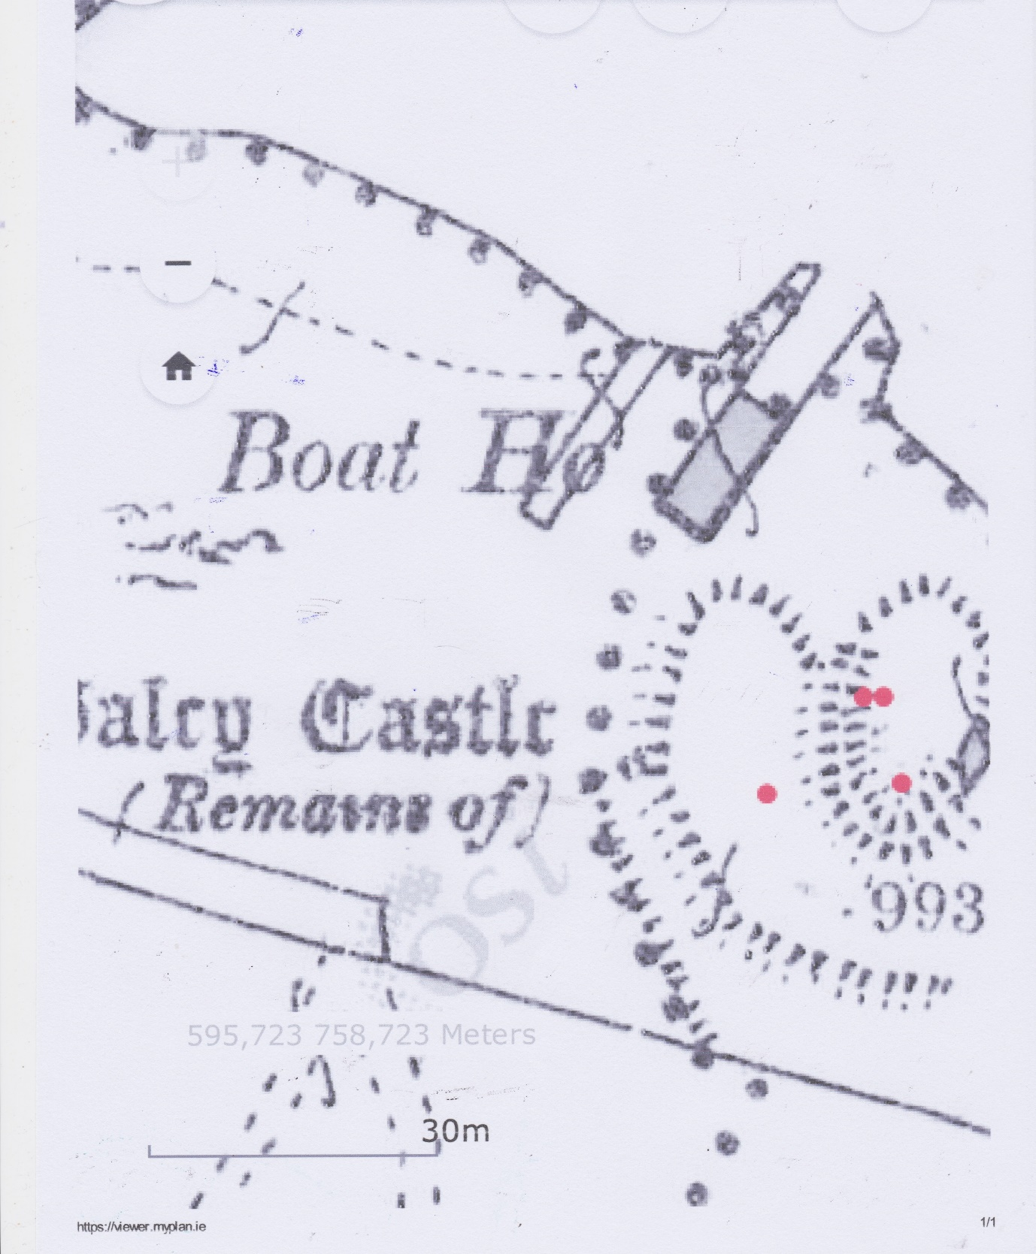

NATIONAL MONUMENTS:
Record Number: RO042-045001-
Classification: Castle - tower house
Scheduled for Protection: 1
Description: Situated on the W shore of Galey Bay (dims c. 1 km N-S; c. 1 km E-W), an inlet of Lough Ree, and within the possible ringwork castle (RO042-045002-). William Boy O'Kelly entertained the poets at Gallagh at Christmas 1351 according to a contemporary poem, and Connor na Garroghe O'Kelly of Grallagh was listed as a prominent landowner in 1585 (O'Donovan 1843, 19, 104-05, 122-3). Only the ivy-covered E corner of a four storey structure survives with a grass-covered cairn (dims 27m ENE-WSW; 22m NNW-SSE; H up to 3m) at its base. It was vaulted over the ground floor with a passage in the SE wall at the vault level. (Kerrigan 1996) Compiled by: Michael Moore Date of upload: 24 August 2010
Record Number: RO042-045002-
Classification: Castle - ringwork
Scheduled for Protection: 1
Description: On the W shore of Galey Bay (dims c. 1 km N-S; c. 1 km E-W), an inlet of Lough Ree. William Boy O'Kelly entertained the poets at Gallagh at Christmas 1351 according to a contemporary poem, and it may have been within this enclosure (O’Donovan 1843, 104). This is a subcircular grass and scrub-covered area (dims 50m NNW-SSE; 43m ENE-WSW) defined by the lake shore WNW-E-S and the remnants of an overgrown bank (at W: Wth 5.8m; int. H 0.45m; ext. H 2m) with outer facing stones and an outer fosse (at W: Wth of top 10m; Wth of base 3.2m; D 1m) elsewhere. The fosse is separated by a berm (Wth c. 13m) from a second fosse (Wth c. 5m; D 0.3m) WSW-WNW. There is a causeway (Wth 4.5m) through the inner fosse at W. Tower house (RO042-045001-) is in the interior. Compiled by: Michael Moore Date of upload: 24 August 2010Record Number RO042-045003-
Classification: Redundant record
Scheduled for Protection: 0
Description: On the W shore of Galey Bay (dims c. 1 km N-S; c. 1 km E-W), an inlet of Lough Ree. There is no structure at Galey castle other than the tower house (RO042-045001-) within the inland promontory fort (RO042-054002-). However, two buildings (RO042-134----) are marked on the Strafford map of c. 1636 (Simington 1949, Athlone (338)), but one represents the tower house and the other is placed some distance S of the castle. Compiled by: Michael Moore Date of upload: 24 August 201

ORDNANCE SURVEY:
The boathouse does not appear in the 1837 Ordnance Survey map, but the site is described as Longnamuck Harbour, indicating that this location had been is use as a harbour from the early days of Gailey Castle.
The 1891 Ordnance Survey map (above) shows the boathouse in place, consisting of an outer dock and boathouse.
The 1923 Ordnance Survey map shows the same structures in place.
The current Ordnance Survey map show as larger dock with the building removed.
DESCRIPTION
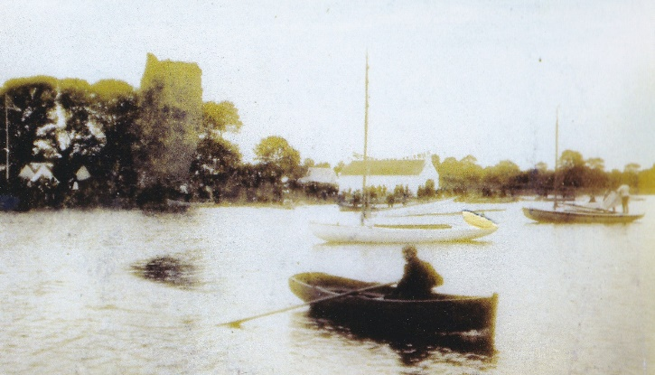
Lord Crofton’s boat house followed a pattern which can be seen in many other sea and lakeside boathouses, such as Lord Sligo’s boathouse at Westport, Lord Erne’s boathouse at Lough Erne, the Bond Boathouse near Newtowncashel, Co. Longford, or Mr O’Conor’s boathouse at Lough Allen Island. These boathouses can be divided into two categories, wet and dry. The wet ones enabled the boat float into the boathouse, while the dry ones used a slipway, railway tracks, a bogie which ran on the tracks, with a winch to pull the boat into the boathouse. Lord Crofton’s boathouse is of the wet type.
Figure 1. Gailey Castle with the boathouse beyond taken during Galey Bay regatta c. 1890.
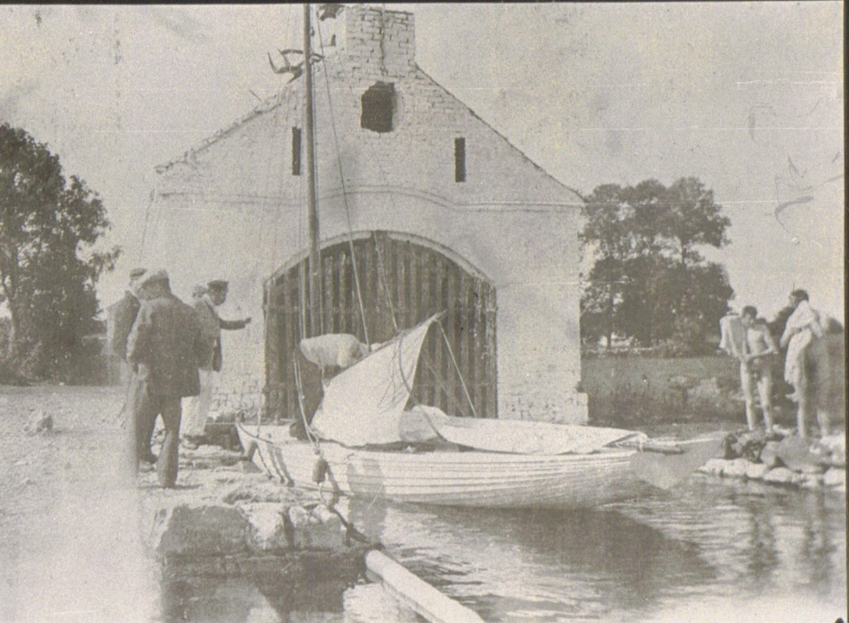
The building consists of a single cell c. 15m. long by c.9m. wide standing on a limestone dock built using semi shaped limestone stones coursed horizontally at c.300mm centres. The super- structure would have been a single bay, built of locally sourced white clay brick, surmounted by a slate roof. There would have been a secure pedestrian door possibly at the south-west end.
The north-east end consisted of four openings, at the top was an approximately rectangular opening c.450mm wide by c. 600mm tall. It’s purpose was to throw light deep into the boathouse. Below it were two vertical narrow slots positioned symmetrically which are c. 100mm wide. They appear to provide ventilation. The main opening was a wide gateway with a single point arch formed in brick, with splayed arrises, which was c. 4m. wide by 4.5m high extending down into the water. There seems to have been a roughly constructed ledged and sheeted gate made of timber with the sheeting consisting of 100mmx 25mm timbers spaced at 200mm centres. It may have been that it was originally intended to leave the opening clear but security requirement required some form of door. Internally there would have been a walking deck with limestone paving c. 300mm above water level. At the South-west end there was a small square chimney stack which implies that there was a pot-bellied stove or similar to keep the interior warmer and dryer. A similar square chimney existed at the north-east end, but it was probably just decorative with no function. The two end gable extend above the level of the slating which are flashed into the gables. There may have been a plinth offset in the brick on the side and back elevations.
Figure 2. Lord Crofton's boathouse with Lord Kingston of Kilronan Castle in the yachting cap holding his Colleen Class yacht ‘Meelagh’ during the Gailey Bay Regatta c. 1910.
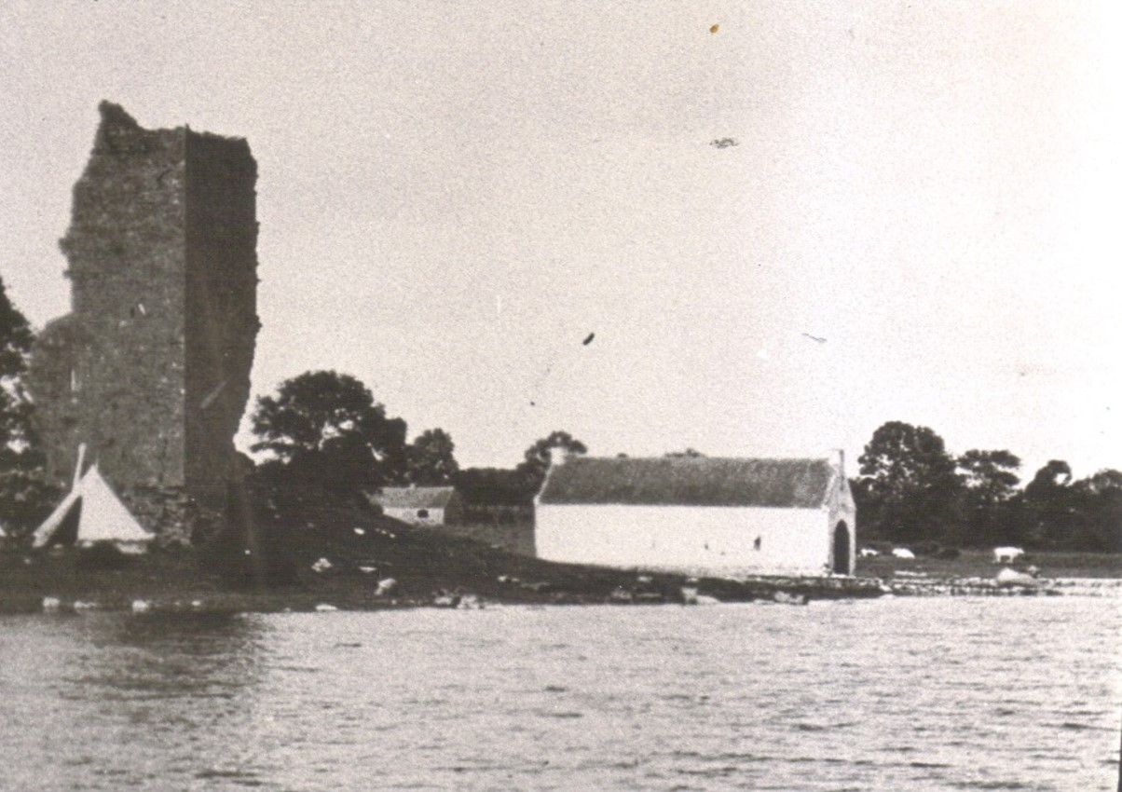
Figure 3 Lord crofton's Boathouse when the Water wags visited in 1904.
ARCHITECTURAL SIGNIFICANCE OF THE BOATHOUSE
For hundreds of years, Knockcroghery village was renowned for one product, white clay pipes.It would appear that the bricks used for the boathouse were made from Knockcroughery clay, the only known building in Ireland to use this material.
AGE OF BOATHOUSE
When was the boathouse built? We are unable to throw much light on this. There are a number of options.
1) It was built as a safe harbour for the Gailey Bay regattas which took place from 1872 until the 1920s. The earliest Gailey Bay Regatta took place in 1872, so it is quite possible that it was built about that time.
2) The railway cam e to Knockcrockery and Mote Park in 1860, so the boathouse may have been used to provide quick access to Athlone, Longford and surrounding towns and to the adjoining estates, in which case it would have been built for a steamer prior to 1860.
PURPOSE OF THE BOATHOUSE
What was the purpose of the boathouse? Several features of the boathouse point to its purpose.
- It had a roof, thus it was not suitable for storing sailing yachts with their masts up.
- There is no evidence of a crane or derrick for the unstepping of masts.
- It suitable for a motor boat.
- The only motor boats in the 1870s were steamers, powered by coal or wood.
- There is no location for the storage of coal or wood so the steamer would have picked up fuel at Athlone or Lanesborough.

Figure 4. Typical Shannon steamer of the 1870s. there is no evidence available to show what type of boat Lord Crofton owned.
WHO BUILT THE BOATHOUSE:
The options would be any of the following:
- Edward Crofton 2nd Baron Crofton (1806-1869)- Married to Georgina nee Paget.
- Edward Henry Churchill Crofton 3rd Baron Crofton (1836-1895)
- Arthur Edward Lowther 4th Baron Crofton (1866-1942)
Based on the above, Edward Henry Churchill Crofton did not become Lord Crofton until 1869 and continued until 1895 which corresponds with the greatest days of the Gailey Bay regatta. Thus, it is most likely that it was Edward Henry Churchill Crofton 3rd. Baron Crofton who built the boathouse.
WHO DESIGNED THE BOATHOUSE:
Due to the simplicity of the design, and it’s lack of stylistic architectural features, it is most likely that it was designed by a member of the Crofton family and not by an Architect. Capt. the Hon. Francis George Crofton (1838-1900) may have designed it. He certainly had the necessary skills. He was born in Roscommon on 7 June 1838, son of 2nd Baron Crofton and Lady Georgina (nee Paget). He served in the British Navy for many years, visiting many harbours between here and China, where he served during the Opium Wars. When he retired from the navy, he was appointed harbourmaster of Kingstown Royal Harbour (Dun Laoghaire) in 1878. I believe he had the skills and the motivation to design the boathouse.
DISTANCE BETWEEN THE BOATHOUSE AND MOTE PARK
Mote Park, Ballymurray is the ancestral home of the Roscommon branch of the Crofton family. It is located five and a half miles from the waters edge of Lough Ree at Gailey Castle. Presumably this distance would have been covered by horse and trap once the boathouse was built.
HISTORICAL REFERENCES
- The Roscommon Messenger printed an advertisement on 10 August 1861 which read: ‘Yacht for sale, a nine ton cutter yacht with light duty of water, seen lying at Gailey Bay……….James Murray Roscommon.’ Does this imply that the boathouse was built by 1861? Not necessarily, as there is no reference to the word boathouse. The word ‘lying’ may imply that she was lying at anchor.
- The National Library of Ireland holds the diary of Lady Georgina Crofton, widow of Edward Crofton 2nd Baron Crofton (1806-1869).
Lady Georgina made many references in her diaries during the 1870s of ‘The boys went to Gailey for the regatta’ or ‘The boys went to Gailey on their shooting trip with Lord Castlemaine.’ Lord Castlemaine lived at Moydrum Castle near Athlone and owned Hare Island, Lough Ree, which was an ideal shooting estate with a shooting lodge and a sheltered harbour. When she referred to ‘the boys’ she was referring to her children Edward Henry Churchill Crofton b. 1834, Hon. Charles St. George Crofton b.1836 and Hon. Alfred Henry Crofton b. 1837.
- During the Gailey Bay regattas, most of the competitors were self-sufficient living on their house-boats and racing in their yachts. Nobody needed to come ashore unless for staple supplies from Knockcroghery village, or if they were staying at Mote Park. Georgina Crofton’s diaries comment on when Lord Kingston or Lord Castlemaine came for dinner and to stay overnight.
- In the Gailey Bay regatta report of 21 July 1888 in the Roscommon Journal there is reference to a greased pole competition for the benefit of the public. It is not possible to run such a competition off a rocky shore. It is most likely that the pole was laid across the dock outside the boathouse and removed before the yachts returned. In this wat the competitors who fell off the pole fell into deep water.
- On 26 May 1892 Roscommon Journal published and advertisement: ‘ Yacht for sale, cruising yacht Siren 5 tons (winner of several cups and prizes) which may be examined before ballast is shipped at Gailey Bay, Lough Ree………..S.St. Lawrence Burke, The Abbey, Roscommon’ There is only one way of shipping ballast, and that is to bring a yacht to a quay, which forms the external part of the boathouse, and lift out the stones, iron or lead by hand. This must have been done at Lord Crofton’s boathouse.
- In 1898 the Royal Society of Antiquarians travelled to Galey Bay on the steamer Countess of Cadogan under the guidance of their President the Right Honourable the O’Conor Don. Reports do not tell is if they came ashore. If they did they would have used the quay outside the boathouse.
TODAY
Today the remains of Lord Crofton’s boathouse lies abandoned and vandalised with most of the original bricks lying deep in the clear water. The docks are usable but there are no cleats to which boats can be tethered.
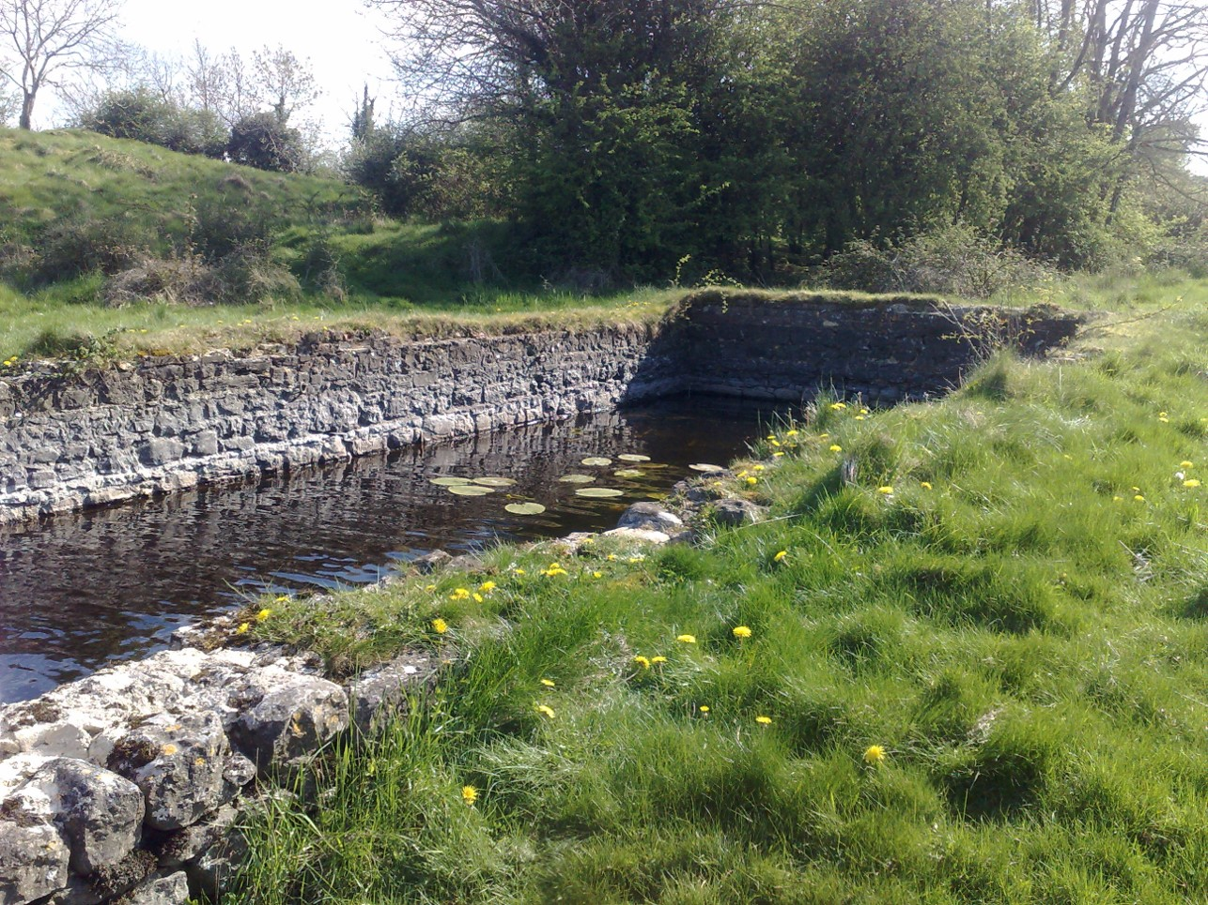
Figure 5. View of the Remains of the boathouse in 2015 with the limestone retaining walls still in good condition, and lilies growing where the boatshed should be.
In 2015 the Water Wag Club of dinghy sailors travelled from Dun Laoghaire to Lecarrow by road, and sailed from Lecarrow to Gailey Bay and Gailey Castle to recreate their club trip of 1904.
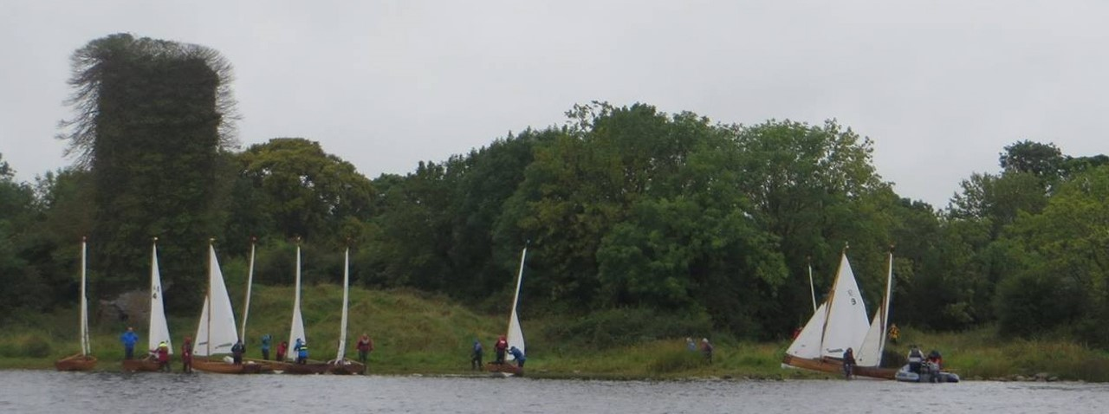
Figure 6 In 2015 the Water Wags of Dun Laoghaire made an expedition from Lecarrow to Gailey Bay. The boats on the right are in the remains of the boathouse.
CONCLUSIONS
Gailey Castle has been a place of great gatherings of people since William MacDonough Moyneagh O’Kelly invited all the poets, Brehons, bards, harpers, gamesters or common kearrroghs, jesters and others to Gailey castle at Christmas 1351. The castle marked the boundary of HyMany, the land of the O’Kellys over several hundred years. Perhaps it is very sad that this place which has so many stories to tell has been left abandoned.
By virtue of being built of Knockcroghery bricks, the boathouse would have been a unique structure.
REFERENCES:
Images:
North front of boathouse: Delany family collection, Dun Laoghaire.
Galey bay Regatta: Lough Ree Yacht Club archives.
Gailey bay regatta Programme: Lough Ree Yacht Club archives.
Water Wags at Gailey Castle: Water Wag Club archives held by Vincent Delany.
Shannon Steamer: Jocelyn Sanders collection.
Documents:
Dun Laoghaire Rathdown Co. Co., Programme of ‘Bicentenary of Dun Laoghaire harbour, 18 May- 10 Dec 2017’ Exhibition (Dun Laoghaire, 2017) and available on line.
Manuscripts
Lady Georgina Crofton diaries: NLI Mss 4060-4072.hes
Vincent Delany, ‘Yachting and yachtsman on the River Shannon 1830-1930’ Unpublished NUIM MA history thesis.
Newspapers
The O’Kellys of Hymany in Westmeath Independent, 26 June 1909.
The Royal Society of Antiquarians in Westmeath Independent, 18 June 1898.
Roscommon Journal, various dates.
The Roscommon Messenger, various dates.

