KILMORE ST. FEIDHLIMIDH CATHEDRAL DOOR
By Christopher Kirk
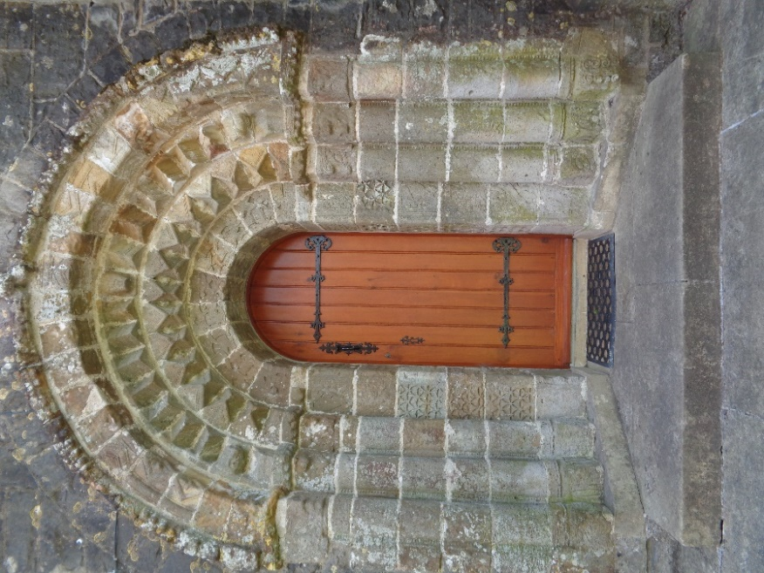

My Pevsner guidebook to South Ulster architecture describes St. Feidhlimidh (CofI) Cathedral; ‘Set in a highly picturesque enclave shrouded by venerable oaks and sycamores’. The cathedral was built in 1860 during a period of Second Reformation and dedicated to the memory of Bishop William Bedell, who died and was buried here in 1642. Bedell, a noted church reformer was consecrated Bishop of Kilmore and Ardagh in 1629 and is credited with the first translation of the Old Testament Bible into Irish.
The cathedral church of St. Feidhlimidh lies just 5km distance from Cavan town, in the rural townland of Kilmore Upper and the Barony of Loughtee. The name Kilmore (Cill Mhoir) meaning ‘Great Church’ indicates it as the site of an ecclesiastic diocese church.
The subject of this paper describes an Irish Romanesque doorway, now seemingly incongruously set in a chancel north wall, employed as a vestry door. This then leads us back to another period of Irish Church history which began as a ‘reformation’ of the church during the 12th century.
The early Irish Church was led by great saints like Patrick, Columba and Meadhog (St. Mogue) who created a system of monasticism in Ireland. These monasteries grew to be powerful; where Abbots exercised jurisdiction in the monasteries and in the Dioceses, not the local Bishop who was usually a monk of the Abbey under the jurisdiction of the Abbott for Confirmations and Ordinations.
Over time reforms and changes were needed to bring the Irish Church system into line with other Christian churches throughout Europe. One of these church reforms took place at Kells and Mellifont in 1152, with a synod of Irish bishops and kings to discuss the progress of changes taking place since an earlier synod at Rathbreasail in the year 1111 had provided for twenty six new dioceses to be set up throughout the country. Ulster had five as had Connacht with an extra two in Meath and these together with the Archbishop of Armagh gave a total of thirteen in the northern province. The southern province at Cashel had a similar arrangement of diocese under an Archbishop of Cashel. The Kingdom of Breifne at that time was part of Connacht and by 1152 would become further divided to include parts of Meath including Kells.
During the twelfth century Kells and Mellifont were already important centres for monasticism with Cistercian monks and Augustinian Canons Regular in both locations. In the Augustinian abbey at Kells were Canons drawn mainly from Breifne Gaelic speaking areas which came under the jurisdiction of the Abbot of Kells. Breifne then stretched from Kells all the way to Sligo, and while the new diocese had no appointed Bishop, cathedral or other significant buildings some important decisions still had to be made over finding a mid-point for the new diocese for any future Bishop to have jurisdiction and manage his parishes.
One of the key reformers in the twelfth century Irish Church, was St. Malachy, then Archbishop of Armagh. He had gained practical knowledge of the monastic system in France, where he concluded that the best means of bringing about reform was to introduce Augustinian rule. He copied the Cistercian rule from St. Bernard of Clairvaux and he introduced this contemplative Order of Mellifont and elsewhere to concentrate on prayer, learning and study. He copied the Augustinian Rule from St. Gervaise, Abbot of the Augustinian Canons Regular at Arrouaise and directed the Cathedrals and monastic foundations of Ireland to follow this rule.
It is important to note that these Canons Regular members of Augustinians at Arrouaise were not monks; they were secular priests living the common life of prayer, but also dedicated to the pastoral ministry in the area around.
A mid-point solution for Breifne in the new Tir Briuin diocese was found within the pre-existing (St. Mogue) Drumlane abbey, which provided a church where clerics from Augustinian Canons Regular could form a new St. Mary’s priory under the jurisdiction of the Abbot of Kells. Such a decision would undoubtably have met with approval from the Archbishop of Armagh and patronage was found with the then King of Breifne, Tighearnan mor O’Ruairc. (1124-1172). This was not the perfect solution for a bishop to form a diocese, but it did provide for a centre where clerics could learn the ways of operating a parish system. Over the following two centuries many hurdles would need to be crossed before a cathedral could be built, especially as most of the existing parishes came under the control of either Kells or the Benedictine monastery at Fore. It would be around 1455 before a cathedral was finally built, to became known as Kilmore, situated close to the flourishing O’Reilly market town of Cavan
Turning now to the Romanesque door located in the present nineteenth century St. Feidlimidh cathedral building. The style of doorway is not very dissimilar to other stone crafted doorways found in churches and monasteries around the country typical of the mid-twelfth century period. These doorways are particularly noted for their (Scandinavian) Irish -Romanesque style of artworks. Where every doorway is a unique piece of architectural sculptured genius. Remaining examples exist today at Clonmacnoise, Killeshin (Ferns diocese) and Annaghdown, (Co. Galway). Nearly all were constructed in the twelfth century period after the Synod of Kells and mostly before the Anglo-Norman invasion which took place in 1170.
One of the features of these doorways are the carved images, which in ways tell their own stories representing passages from the gospels. Some are like the iconic artworks seen in the Book of Kells
Local stories suggest that the Kilmore doorway at St Feidlimidh cathedral had come originally from a Premonstratensian priory located at Trinity Island in Lough Oughter, the origins of which date from the mid-thirteenth century and built as a daughter church of a similar priory located on an island in Lough Ce, near Boyle in Co. Rosscommon. Both priories came originally under the patronage of Cathal O’Reilly from land that was gifted to the Abbot of Lough Ce, a small order of canons regular following a vow of silence and manual work. Later it was Sheridan’s who provided patronage to the Trinity Island priory.
Trinity Island was not the seat of a bishop and could therefore never be regarded as the ‘Great Church’ of Breifne or Kilmore. Another island abbey church located nearby at Slanore pre-existed the Synod of Kells and no record exists of its provenance within Kilmore.
The Augustinian priory at Drumlane was the mid-point of the O’Ruairc (O’Rourke) kingdom of Breifne until the kingdom became divided into east and west Breifne from the mid thirteenth century. The O’Reilly clan had become powerful under Norman influence in east Breifne, the town of Cavan flourished as a market town and included a new Franciscan friary during the fourteenth century. Drumlane was described as a town in the Annuls of Clonmacnoise, but clan feuds and battles between the rival factions eventually took their toll on Drumlane where both O’Rourkes and O’Reilly clan chieftains were traditionally buried. The town of Drumlane was finally burned by John O’Reilly in 1488 after feuds within the O’Reilly clan.
The dissolution of monasteries around 1538 brought an end to the Augustinian monastic priory at Drumlane. The large church continued to be used by English and Scottish settlers after the Plantation, until around 1820 when a new parish church of St. Columba was built. The roof of the old Drumlane church was then removed and the structure was left to decay. Later in the nineteenth century the structure was taken over as a National Monument by Board of Works and later OPW. The old St. Mary’s priory buildings fell into decay since the time of the Plantation and over time became ruinous, stones were then stripped by local farmers. All that remains of the priory today are wall fragments and a footprint of earthworks where buildings once stood.

Images and symbols found on St Feidhlimidh Cathedral Doorway
